Sunday | Monday | Tuesday | Wednesday | Thursday | Friday | Saturday
 |  |  |  |  | 1  May Day | 2
3 | 4 | 5  Cinco de Mayo | 6 | 7 | 8 | 9
10  Mother’s Day | 11 | 12 | 13 | 14 | 15 | 16  Armed Forces Day
17 | 18  Victoria Day (Canada) | 19 | 20 | 21 | 22 | 23
24 | 25  Memorial Day | 26 | 27 | 28  Shavuot Begins | 29 | 30
31

Pennington Square Assisted Living |  |  |  |  | 2:00 Doorway Bingo  3:15 Wine & Cheese
 | 10:00 Wayne Zion Audio Service | 1:00 May Activity  Happy Birthday Freda! | 2:00 Card Games  *In Apartments | 1:00 Manicures  *In Apartments | 2:00 Doorway Bingo  3:15 Wine & Cheese
 | 10:00 Wayne Zion Audio Service | 10:00 Doorway Exercise | 1:00 Hallway Balloon Volleyball | 10:00 Doorway Exercise | 2:00 Doorway Bingo  3:15 Wine & Cheese
 | 10:00 Wayne Zion Audio Service | 10:00 Doorway Exercise | 10:00 Noodle Ball | 1:00 Manicures  *In Apartments | 2:00 Doorway Bingo  3:15 Wine & Cheese
 |  | 2:00 Spring Craft | 1:00 Hallway Balloon Volleyball | 10:00 Doorway Exercise | 2:00 Doorway Bingo  3:15 Wine & Cheese  Happy Birthday Jake!
Happy Birthday Frank! | “Everyday may not be good but there is something good in everyday”  Activities are Subject to change!
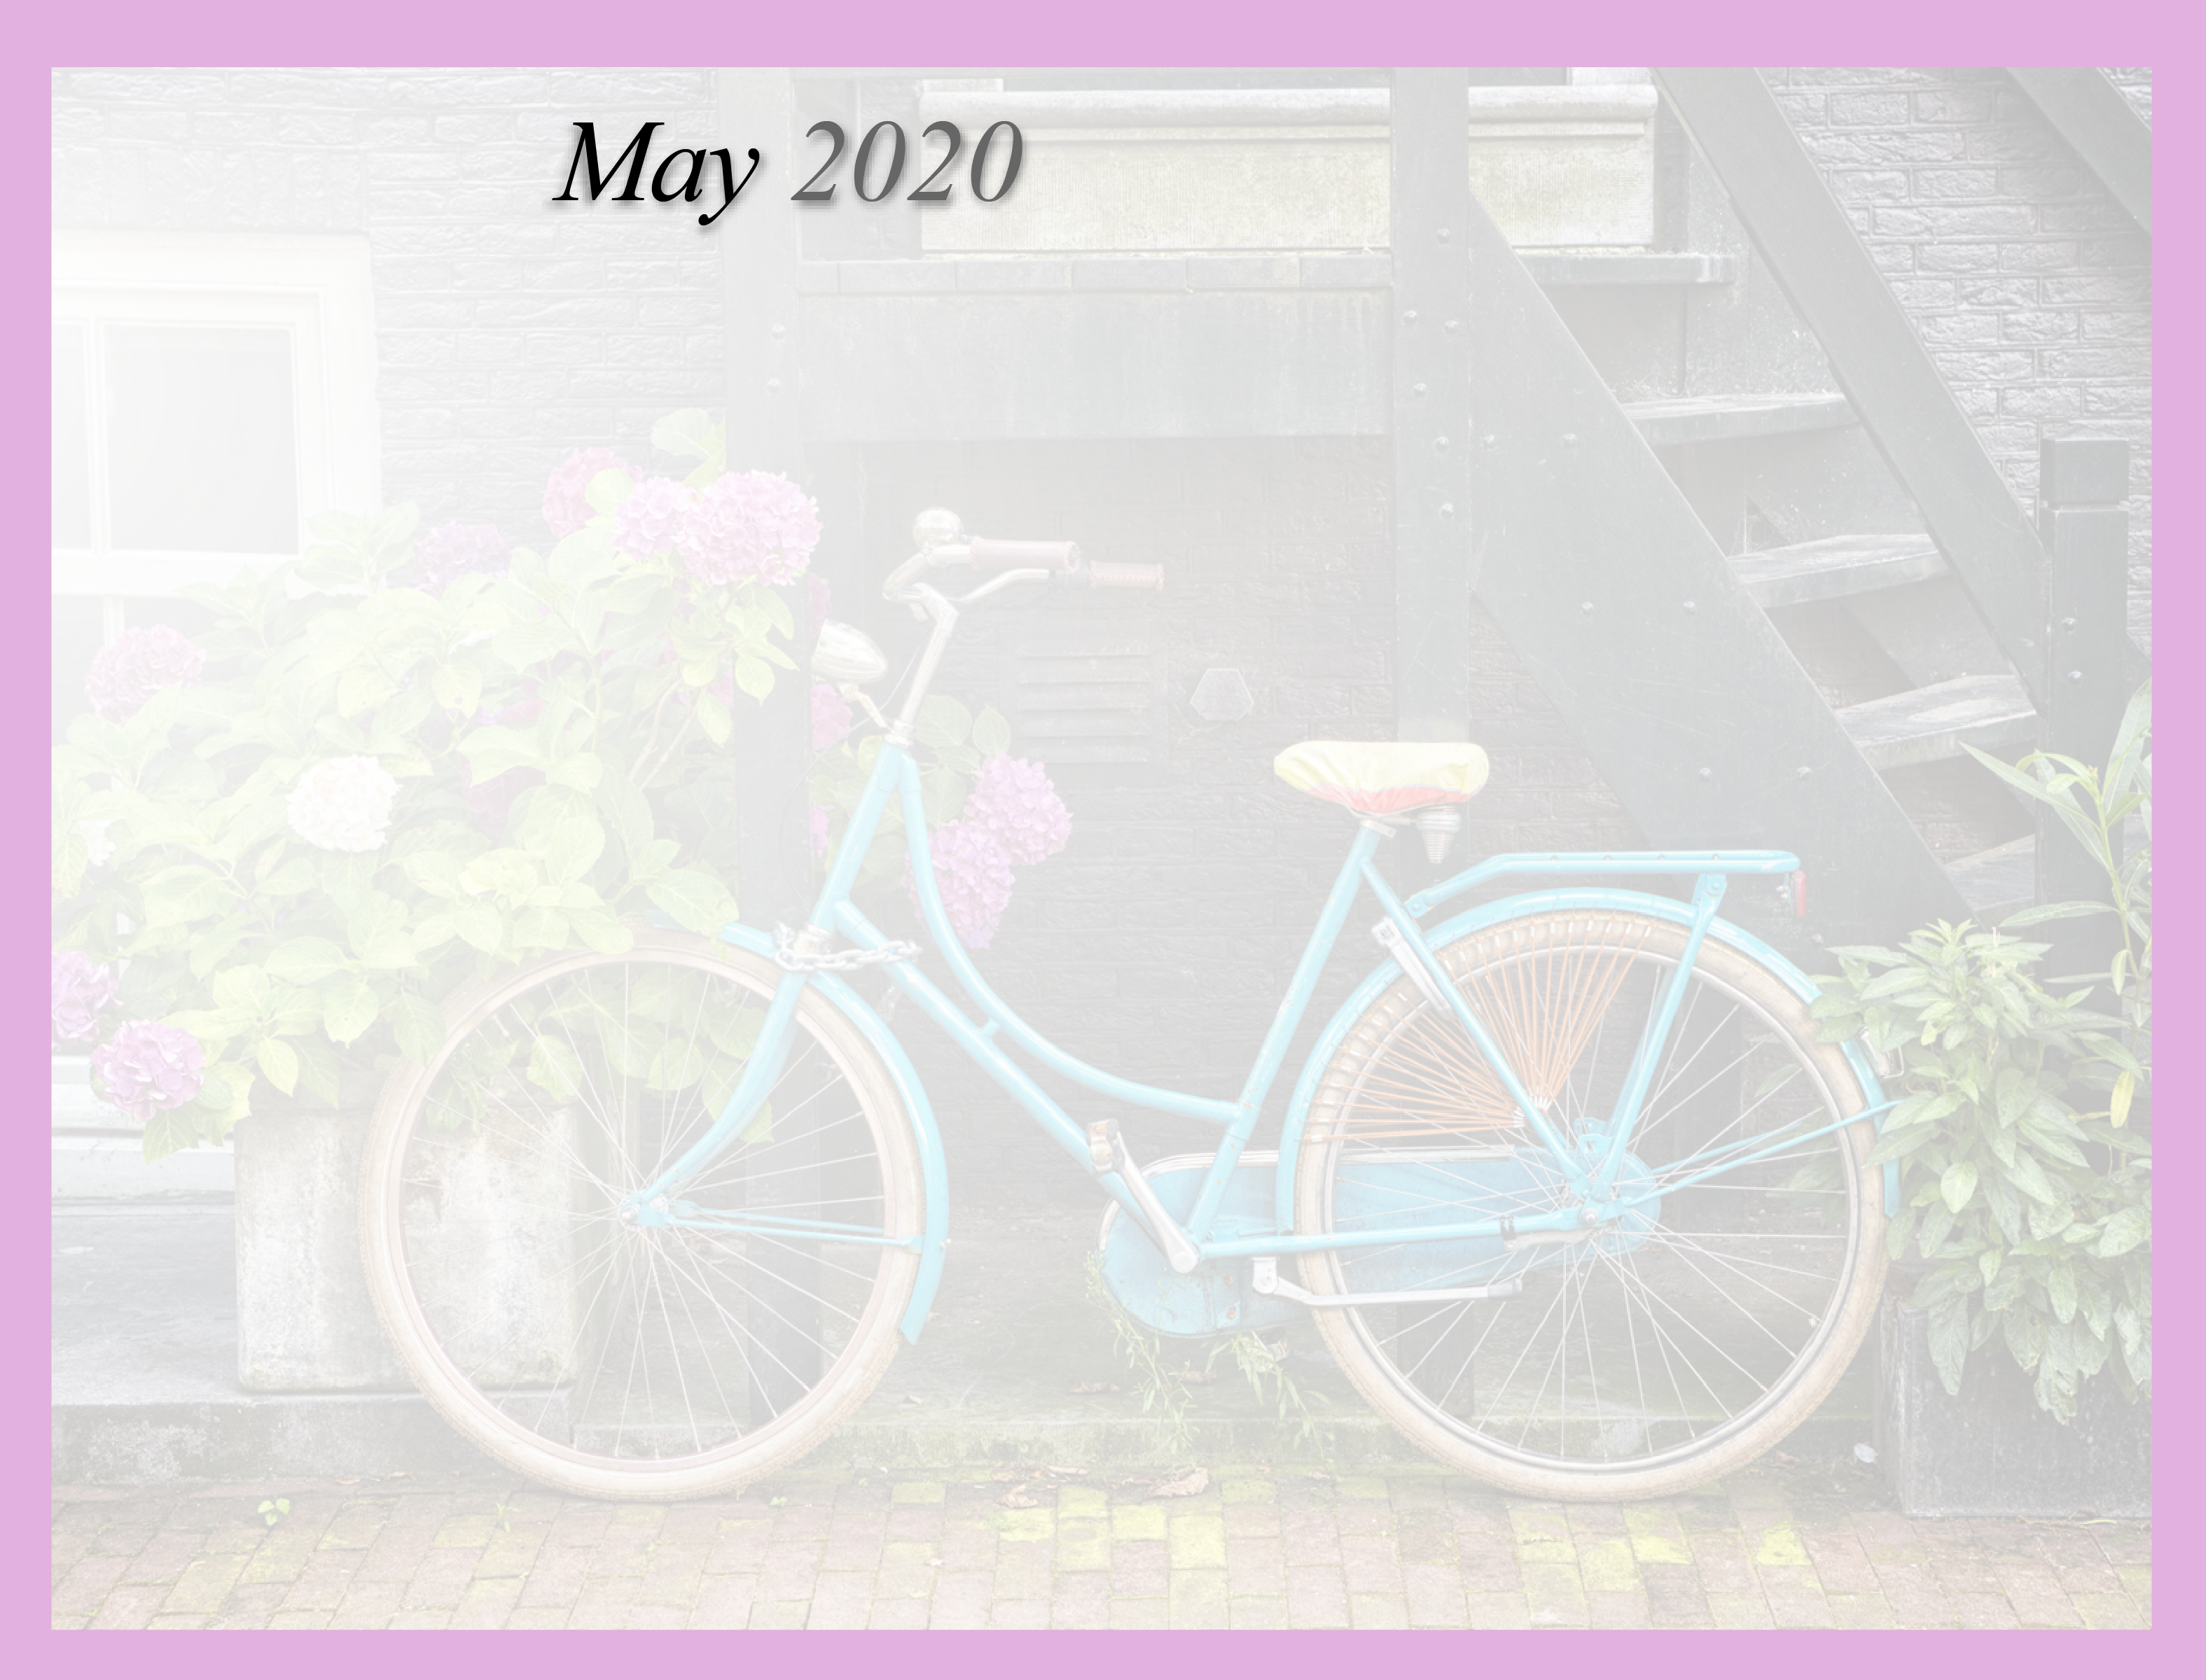
1:1 Activities & Independent Activities

